To: Professor Martinez

From: Murtaza Amjad

Date: 04/17/2024

Subject: Lab 5 Technical Memo

The lab goal was to optimize the Arduino software and hardware from the previous lab 4 and use interrupts so that each task is done and moved on to the next task. The parts used in the lab were the Arduino R3, the joystick, temperature sensor, light sensor, LED, wires, and USB power cable. There are three different outputs: j for the output of the joystick, T for the output of the temperature, and L for the output of the light sensor.

Some of the problems I faced during this lab was forgetting to install the library so that I was able to use interrupts. There were a few problems with getting the color to work due to connecting them incorrectly at first.

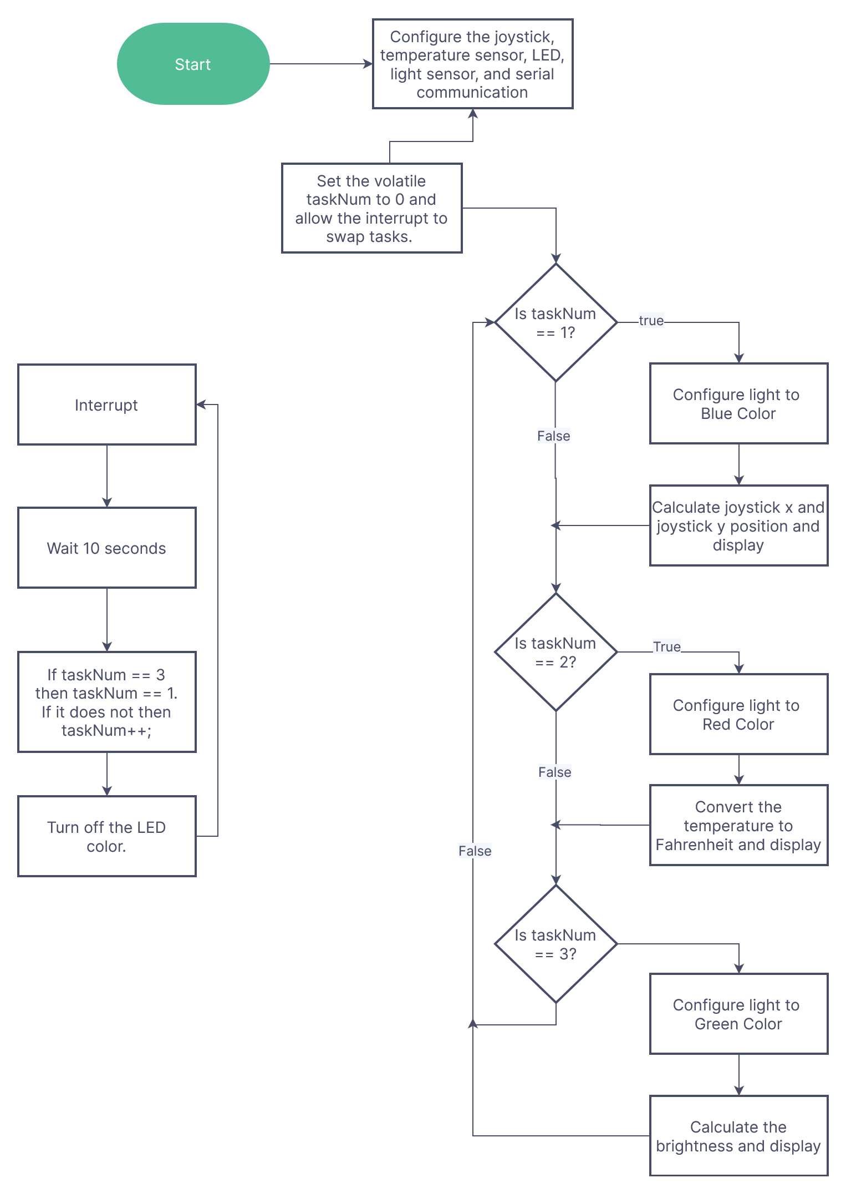

Figure 1. Program Flowchart

The flowchart quickly shows you how the program runs and what happens at each step of the way. If you follow the chart, you will see it describes what is happening in the demonstration. It helps give a step-by-step process on what’s happening when certain things go into effect.

The result of the lab was a successful program. This lab successfully implemented the periodic interruptions, which helped the task switch over time. This lab can become more complex by having an option to turn off the interruptions and go back to reading data from the serial monitor like the previous lab, being able to switch between automatic task swaps and manual task swaps.

Appendix:

Code:

#include <TimerOne.h>

//all my variables

int joystickX = A1;

int joystickY = A2;

int temperatureSensor = A4;

int lightSensor = A5;

int greenLed = 11;

int blueLed = 10;

int redLed = 9;

int choice;

int Vo;

float R1 = 10000;

float logR2, R2, Temperature;

float c1 = 0.001129148, c2 = 0.000234125, c3 = 0.0000000876741;

String xZone;

String yZone;

volatile int taskNum = 0;

void setup() {

Serial.begin(9600);

pinMode(greenLed, OUTPUT);

pinMode(blueLed, OUTPUT);

pinMode(redLed, OUTPUT);

Timer1.initialize(10000000);

Timer1.attachInterrupt(swapTasks);

}

void loop() {

if (taskNum == 1) {

digitalWrite(blueLed, HIGH);

choice = 1;

}

else if (taskNum == 2) {

digitalWrite(redLed, HIGH);

choice = 2;

}

else if (taskNum == 3) {

digitalWrite(greenLed, HIGH);

choice = 3;

}

//Repeat choice until new one is chosen

//print joystick output

if (choice == 1) {

int x = analogRead(joystickX);

int y = analogRead(joystickY);

if (x < 342) {

xZone = "right";

} else if (x > 682) {

xZone = "left";

} else {

xZone = "center";

}

if (y < 342) {

yZone = "down";

} else if (y > 682) {

yZone = "up";

} else {

yZone = "center";

}

Serial.println("(" + xZone + "," + yZone + ")");

}

//print temperature output

else if (choice == 2) {

Vo = analogRead(temperatureSensor);

R2 = R1 \* (1023.0 / (float)Vo - 1.0);

logR2 = log(R2);

Temperature = (1.0 / (c1 + c2\*logR2 + c3\*logR2\*logR2\*logR2));

Temperature = Temperature - 273.15;

Temperature = (Temperature \* 9.0)/ 5.0 + 32.0;

Serial.print("Temperature: ");

Serial.print(Temperature);

Serial.println(" Fahrenheit");

}

//print light output

else if (choice == 3) {

int light = analogRead(lightSensor);

int brightness = map(light, 0, 1000, 100, 0);

Serial.println("Brightness: " + String(brightness) + "%");

}

delay(100);

}

void swapTasks(){

if (taskNum == 3){

taskNum = 1;

}

else {

taskNum++;

}

digitalWrite(greenLed,LOW);

digitalWrite(blueLed, LOW);

digitalWrite(redLed, LOW);

}